|  |
| --- |
| North Metropolitan TAFE |
| Shire of Chittering Client Project Action Plan 2024 |
| |  | | --- | | Douglas Fergusson  Nathan Bransby  Yang Tyin ‘YT’ Lim  Sangay Thinley  Bianca Ishikawa  Daniel Mulenga  12-06-2024 |   Semester 1 2024 |

Content

Executive Summary 2

Introduction 3

Overview of the Issue 3

Background 3

Existing Solutions 3

Stakeholders 4

Communication 4

Version Control 5

Task Outline 5

Authorization & Authentication 5

Rates Payments 6

Push Notifications 7

User Interface Enhancements 7

Testing & Deployment 7

Deliverables 7

Resources 8

Project Timeline 8

Risk Management 9

Deadlines 9

## Executive Summary

This report outlines a strategic initiative aimed at enhancing the technological infrastructure of the Shire of Chittering to improve community engagement and streamline administrative processes. Leveraging insights from the Shire’s Strategic Community Plan and Corporate Business Plan, we propose expanding our existing mobile applications.

This approach utilizes established technologies and frameworks, ensuring continuity and ease of adoption by the community. By building on the existing Xamarin and Flutter apps, we aim to introduce advanced functionalities such as real-time notifications and integrated payment systems, which align with the Shire's strategic objectives of fostering community engagement and enhancing administrative efficiency.

A minimum viable product (MVP) is achievable by the end of 2024 with push notifications, a rate balance display and payment functionalities, while also ensuring the current existing features (fire danger ratings and problem reports) are included as well. Care will be taken to make sure the application is easily maintainable and scalable for future feature-sets based on evolving community needs.

## Introduction

### Overview of the Issue

The Shire of Chittering faces challenges with high communication costs and inefficient processes in handling council rates payments. Initial consultations with the Shire's staff and review of community feedback identified a pressing need for improved digital engagement platforms, ease of access for Chittering rate payers & improvement of bushfire danger communications. This project was initiated to address these concerns by leveraging modern technology to create more efficient, cost-effective awareness, communication and payment solutions.

### Background

In partnership with North Metropolitan TAFE, the Shire of Chittering has engaged in technological enhancements over the past three years, focusing on developing solutions that improve community awareness by indicating the active Australian Fire Danger Rating System (ADFRS) for the Chittering Region as well as improving the quality of community and administrative interactions.

### Existing Solutions

* The Shire’s website is managed with Spark CMS, a SaaS solution deployed with CouncilConnect by Market Creations Agency, a local company.
* The main Entity Resource Planning (ERP) solution is SynergySoft which is hosted centrally on Shire premises. Reports for rates payments are generated here.
* Previous solutions prepared by TAFE students include a Xamarin app and a Flutter app, which have been moderately successful but require enhancements to meet evolving community needs.
* A WordPress website was produced by 2019 TAFE students to replace the SparkCMS solution, but was ultimately not adopted by the Shire.
* Rates payments are facilitated through BPoint.

## Stakeholders

* Shire of Chittering
  + Executive Stakeholder / Chief Executive Officer
    - Melinda Prinsloo ([melinda.prinsloo@chittering.wa.gov.au](mailto:melinda.prinsloo@chittering.wa.gov.au))
  + Rangers, Emergency Services & Planning
    - Jodie Connell ([jodie.connell@chittering.wa.gov.au](mailto:jodie.connell@chittering.wa.gov.au))
  + Shire Staff (Rates Department)
  + Residents
  + Business Owners
* North Metropolitan TAFE
  + Supervising Lecturer
    - Aaron Clifford ([aaron.clifford@nmtafe.wa.edu.au](mailto:aaron.clifford@nmtafe.wa.edu.au))
  + Developers and Project Managers
    - Douglas Fergusson ([j233195@tafe.wa.edu.au](mailto:j233195@tafe.wa.edu.au))
    - Nathan Bransby ([v141198@tafe.wa.edu.au](mailto:v141198@tafe.wa.edu.au))
    - Sangay Thinley ([20095373@tafe.wa.edu.au](mailto:20095373@tafe.wa.edu.au))
    - Yang Tyin *'YT'* Lim ([20103962@tafe.wa.edu.au](mailto:20103962@tafe.wa.edu.au))
    - Daniel Mulenga ([20095356@tafe.wa.edu.au](mailto:20095356@tafe.wa.edu.au))
    - Bianca Ishikawa ([20037983@tafe.wa.edu.au](mailto:20037983@tafe.wa.edu.au))

## Communication

Regular, recorded communication will be key to the project’s success and will be achieved using the following methods and tools:

* Email will be the primary, formal method of communication, making sure to CC all relevant stakeholders where appropriate.
* Microsoft Teams instant messaging service will be used for more frequent, informal communication with the Shire, TAFE & students throughout the development of the application.
* Meetings will occur either in person, or remotely via Microsoft Teams to discuss the project at all major milestones throughout the project timeline.
  + A Microsoft Teams chat has been created with all relevant stakeholders.

## Version Control

* Adopt Git and GitHub for source and version control to manage and track changes in the project efficiently.
* Utilize GitHub Projects to coordinate tasks and milestones, ensuring all team members are aligned and informed of project progress.
* Use feature branches and pull request methodologies to maintain transparency on development progress.

## Task Outline

The project consists of the following key milestones:

### Authorization & Authentication

Setup Development Environment:

* Configure Integrated Development Environment (IDE) settings for optimal development efficiency.
* Install necessary plugins and configure settings for Flutter development.

User Account Creation:

* Implement user registration and login functionality for two user types: administration and residential.
* Develop secure authentication processes, such as integrating OAuth for enhanced security.
* Design user interfaces for account management features, ensuring accessibility and user-friendliness.

### Rates Payments

* Setup Payment Form:
  + Design and implement a form for users to submit their rates payments easily.
  + Integrate form validations to ensure data accuracy and security.
* Backend Integration:
  + Set up a secure connection to Firebase for storing and managing payment data.
  + Implement backend logic to handle the uploading and retrieval of SynergySoft reports.
* Testing and Progress Reporting:
  + Conduct thorough testing of the rates payment functionality to ensure reliability and security.
  + Regularly update stakeholders on the progress and outcomes of the testing phase.

**Features: Fire rating, Report an Issue**

* Develop a form for users to report issues directly via the app.
* Integrate real-time fire rating updates using a reliable API to fetch and display data.
* Ensure that the user interface for these features is intuitive and seamlessly integrates with other app functionalities.

### Push Notifications

* Setup and Testing:
  + Verify that the push notification functionality is working as expected across different devices and platforms.
  + Implement specific notification channels for harvest bans, fire danger rating changes, and rates payment reminders.
  + Test and implement templated notifications.
  + Provision for custom notifications (any text, as opposed to templated) to be sent via a selected channel.
* User Preferences:
  + Allow users to customize their notification preferences, choosing which notifications they wish to receive.

### User Interface Enhancements

* Tie all the available features together in a cohesive design.

### Testing & Deployment

* User testing against mobile blackspots
* Deploy the app into production.
* Communicate progress.

## Deliverables

* A working mobile app
* Available on mobile app stores
  + Google Play for Android devices
  + App Store for Apple devices
* Firebase (Google) Account
  + Database
  + A backend to push notifications to the app
* Documentation
* Training and demonstrations

## Resources

* Google Account (Firebase / Google Play)
* Flutter Framework (Dart)
* Codebase 1
* Codebase 2
* Firebase (Spark Plan/ Free Tier) Docs
* BPoint Docs
* Stripe Docs
* Emergency.gov.wa.au / BoM Docs
* Shire assets (request via MS Teams)
* Shire administration Team

## Project Timeline

* 6 months
* Semester 2 2024
* Project start: 15/07/2024 (start of NMTAFE semester 2)
* Project finish: 06/12/2024 (end of NMTAFE semester 2)

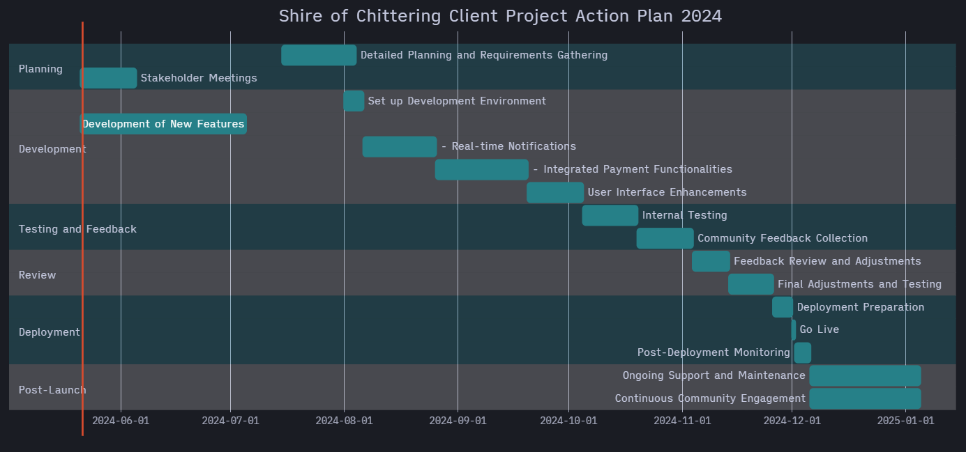

# Deadlines

Project work will be carried out against the proposed action plan. Deadlines which are not met will be communicated diligently via our proposed communication method, Microsoft Teams.

## Risk Management

* Sensitive private data. Our primary recommendation is to utilize Stripe in combination with Firebase with user accounts to accommodate the secure transfer of data such as:
  + Full names and addresses of shire residents and landowners.
  + Outstanding rates payments.
* Costs and onboarding associated with Stripe payments gateway.
  + Whilst it is our recommendation to use Stripe for ease of reporting, accounting and updating with a proven solution, we have available the existing solution- BPay. Contingencies for a minimum-viable-product could utilize a simple redirection to the existing BPay interface.
* Incorrect or outdated information (such as harvest-ban notifications) could have safety implications.
  + Present the user with a disclaimer that they must accept, highlighting that they should not rely solely on the app (much like [www.emergency.wa.gov.au](http://www.emergency.wa.gov.au/))
  + Allow the shire’s fire marshal to set/override the presented local fire danger rating.
  + Potentially fallback to BoM / emergency WA if no update in <x> time.